**Crop type and damage level prediction in view of increasing population growth**

Nithika K1, Dhanush T2, Arvind CB3, Kalki Kartik SL4, Mrs. D. Sathya5

Students 1, 2, 3, 4, Department of Artificial Intelligence,

Assistant Professor5, Department of Artificial Intelligence,

Kongu Engineering College, Erode

***Abstract*—** Based on the population growth rate study, it is anticipated that in a few years, increased crop yield will be required. The main issue preventing from obtaining this production outcome is pests and diseases. It is essential to create some efficient techniques for the automated recognition of different kinds of crops and identification of pests in order to gauge the extent of harm to crops. Various classifications for the purpose to carry out this automation, machine learning (ML) methodologies can be utilized to obtain information and connections from the data set that is being processed on. This study offers an overview of the literature on machine learning (ML) methods applied in agriculture, with a particular emphasis on tasks such as crop type classification and crop damage level prediction. This study aims to support the growth of advanced agriculture and innovative farming by promoting the advancement of techniques that will make farmers conscious of the use of chemical pesticides and herbicides to increase both the yield and quality of their crops.

***Keywords—*** Classification, detection, precision agriculture, machine learning, pests

I. **INTRODUCTION**

A machine learning classification algorithm that takes input in the form of labeled data and predicts output in the form of classes. This is called a multiclass classification algorithm because the dataset has more than two classes.

Domain:

The ability of machines to mimic intelligent human behavior is known as machine learning, an area of artificial intelligence. Systems using artificial intelligence are utilized to carry out difficult jobs in ways that humans can solve issues. You might imagine machine learning to be nothing more than a complex human-performable task performed by a machine following instructions given to it by a human. Having computer models that behave intelligently and like humans is one of AI's main goals. In some situations, such as the following, writing a programme that a machine will follow at random is time-consuming or even impossible. For instance, humans can easily complete the task of teaching computers to distinguish various people in photos. The reason behind this is that unlike robots, people have the ability to see a wide variety of things in photos. Machine learning allows computers (or machines) to learn to program themselves through experience. Since there is no teacher other than our experience, we can succeed in this process and fully

automate our world.

Problem:

We all know that economic losses have increased the frequency

of weather and climate beyond expectations in recent decades. Due to climate change, India has seen an increase in severe thunderstorms in recent years. This hurts the farmers who make a living out of farming. India was once one of the countries famous for agriculture. It's like our identity. But now climate change and other changes are unable to save the country from natural disasters and other shortcomings.

Here we may see some of the elements that damage the crops:

1. Insects

2. Plant disease

3. Nematodes

4. Rodents

5. Weeds

6. Air pollution

7. Pesticides

These are some of the main factors that damage crops. Farmers have decided to mitigate the effects of natural disasters. These are due to management strategies within the business. But there are also risks: B. Natural disasters cost you more than your investment. In such cases, farmers got the idea of ​​agricultural insurance. Through these types of insurance, even if you lose your crops, you may get money to keep them. This kind of politics is widespread all over the world. However, this kind of guideline is useful and not the only way. It's okay to have money instead of food. Only when the harvest is ready will it lead to success. Early humans had no technical knowledge, but now machines can do anything and learn. Here, machine learning can be used to reduce crop damage.

Solution:

Our basic motivation is not just to reduce damage, but to reduce trouble. Therefore, we first use the classification to identify the nature of the problem (or) the reason for crop damage. A multiclass classification algorithm is used here because the dataset may contain more than two classes. First, classify the problem. We will then provide a solution depending on the cause of the damage.

Uniqueness of this project:

We can protect the land and crops from these elements, cost-effectively. This allows you to anticipate solutions, caveats, and problems. This gives many farmers more knowledge that they may not know pesticide limits for key crops. After forecasting, they will learn the true limits.

II. **LITERATURE SURVEY**

**1)** **Convolutional neural networks are used for crop damage control and disease detection.**

For many nations, agriculture—also referred to as tillage or cultivation—is a valuable resource. One of the top nations for producing different crops is India. Crop disease and loss are rising quickly, in addition to production, which is rising daily. crops that are primarily harmed by pests and diseases. Numerous farmers in the nation have stopped farming as a result of these issues due to poverty. We employed convolutional neural networks in this essay. This offers very high accuracy in predicting crop placements at different developmental phases. Python is also used to create a user-friendly GUI. Images are used to capture data sets. Then, we go into great depth on how to use CNNs to locate disease and culture and preserve fewer damaged cultures.

**2)** **Machine Learning Algorithm for Crop Hail Damage Detection Using Time Series of Remote Sensing Data**

Crop failure is frequently caused by hail. In this article, we present a method that employs unsupervised machine learning to identify uniform hail damage. The k-means algorithm was used to cluster pixels into uniform damage zones by taking into account a time period and the indexes rate of growth as input factors. An analysis of soybean, wheat, and corn plots used for algorithm validation revealed that there was significant evidence in 87.01% of the cases that there was a difference in mean damage between the zones within the plots defined by the algorithm. As a result, the method suggested in this paper ought to enhance the accuracy and transparency of hail occurrences while efficiently detecting uniform hail damage zones.

**3)** **A Comprehensive Survey of Machine Learning for the Detection and Prediction of Crop Infections and Pests**

According to recent population growth trends, the output of the world's crops will need to double by 2050. The elimination of pests and illnesses is essential to obtaining this production increase. Therefore, the need for effective techniques to automatically detect, identify, and forecast pests and illnesses in crops is growing. This whitepaper offers a summary of the research on machine learning (ML) approaches that can be applied to the agricultural industry, with a particular emphasis on tasks like disease and pest categorization, detection, and prediction in tomato crops.

**4)** **Crop loss identification using machine learning and satellite remote sensing at the field parcel level**

Crop loss is mostly linked to the growing season, making it extremely difficult to detect crop loss using satellite photography at the plot level. This work investigates whether it is feasible to train a machine learning (ML) model to categorize cropland as having crop losses or not using satellite photos. Applications for classification setups and trained models are numerous. For instance, it makes it possible for government organizations and insurance firms to confirm farmers' claims of crop failure and carry out efficient agricultural surveillance.

**5)** **Based on the Vegetation Index (VI) and UAV Multispectral Imagery, Damage Assessment of Rice Crop after Toluene Exposure**

Utilizing data from unmanned aerial vehicle (UAV) photography, the index of vegetation (VI) was employed in this study to assess agricultural damage brought on by pesticide exposure. Five days after the injury, VI levels were measured. Numerous physiological traits were also discovered. The mean normalized deviation VI (NDVI) of toluene-exposed rice significantly reduced with increasing toluene exposure concentration at the majority of growth stages. This shows that NDVI can depict how plants react when exposed to chemicals. In light of the results, we deduced that UAV imaging-based VI is suitable for crop monitoring, damage assessment after chemical spills, and yield prediction.

**6)** **Utilizing Machine Learning Techniques for Crop Prediction**

The majority of people in India, the second-largest nation in the world, make their living as farmers. They don't experiment with new plant varieties; they just keep growing the same ones. Additionally, I'm uncertain of how much fertiliser to use. This has a direct impact on yield. Consequently, in this study, we developed a system using machine learning methods to enhance farming (Decision Tree and SVM). The best crops for a specific region are predicted using content and weather factors. Additionally, it offers information on how much fertiliser is required for crop growth.

**7) Machine learning for crop prediction**

Farmers struggle to meet the needs of the younger generation. to fight soil erosion and industrial pollutants' role in climate change. Fertilizers are haphazardly added, without consideration for their low quality or amount. To help farmers choose the crops to grow based on climate variables and soil nutrient levels, this study aims to construct the best crop prediction model. In this article, we evaluate well-known algorithms like K-Nearest Neighbors (KNN), Decision Trees, and Random Forest Classifiers using two of his criteria: Gini and Entropy. The results show that random forest provides the highest accuracy out of the three.

**8)** **Using Machine Learning to Find and Predict Crop Diseases and Pests**

To identify and forecast agricultural diseases and pests, utilise this document. Data intake is the process of acquiring data through data preparation from many sources. ML-based applications. Classification of diseases from photos found using various crop-specific convolutional neural network (CNN) architectures. DL methods and object segmentation can be used to detect insects on leaves.

**9)** **Prediction of crop yield using machine learning**

A number of ML algorithms were used to forecast agricultural yield. Temperature, precipitation, and soil type are the most frequently used features, while ANN (Artificial Neutral Network), which is used to estimate crop yield, is the most frequently used algorithm, according to our data. is a difficult task. It involves several challenging steps.

**10)** **High-Resolution Satellite Imagery Fusion and Machine Learning-Based Classification for Crop-Type Mapping in a Semiarid Environment**

In order to identify different plant species, this research intends to take use of and assess the value of multi-sensor classifier-based machine learning classifiers. We employed the artificial neural network (ANN), support vector machine (SVM), and maximum likelihood (ML) machine learning classification algorithms to identify and map plant species in irrigated marginal work. The results showed that merging images captured in the C-band and optical range considerably improved the categorization performance of plant species (overall accuracy of 89%, kappa 0.85), compared to outcomes using optical or SAR data alone.

**11)** **Crop Recommendation Using Machine Learning in the Agriculture Sector**

The factors that affect the inputs and outputs of the agricultural sector are the subject of a wealth of data. These methods are applied to the analysis of particular agriculture industry data. Additionally, soil, environment, moisture, humidity, and temperature are all examined using these techniques. The food grain dataset was used to examine the approach across many variables in this article, which employed Naive His Bayesian taxonomy to identify different plant types. Additionally, we applied a machine-learning strategy to deliver precise harvest advice. End consumers can then make wise selections thanks to this.

**12) A Neural Artificial Network for Nepal's Crop Yield Prediction**

In the agricultural districts of Nepal, this research suggests using artificial neural networks (ANNs) to estimate crop productivity. This experiment demonstrates that the test model can forecast crop yields in Nepal by showing that the trained model made few errors. In this article, ANN is used to forecast yields using information from the Nepalese Sharadha district. Here are some descriptions of AI methods as well as a summary of work on ANN development for agricultural data analysis. This essay concludes with a comparison of data analysis and its use in Nepalese agriculture.

**13)** **A Survey on Crop Prediction using Machine Learning Approach**

This paper's major objective is to use machine learning techniques to identify appropriate crops by acquiring soil and meteorological information, making the agricultural industry more dependable and risk-free for farmers. focuses on strategies and tactics for enhancing agriculture through the provision of technical information and development for Market Trends and Forecasts. Now the conclusion that artificial neural networks are the most effective method for the project after comparing the models.

**14) Machine Learning for the Detection of Plant Disease**

To differentiate between healthy and unhealthy leaves from a created dataset, a random forest is used in this study. The phases of implementation for this suggested study are dataset generation, feature extraction, classifier training, and classification. It can extract image features by using directional gradient (HOG) histograms. Overall, plant diseases may be clearly identified by utilising machine learning to train on sizable publically accessible datasets.

**15) Artificial Neural Network and Crop Prediction Techniques for Predicting Wheat Yield**

The forecasting methods used in the agricultural sector are described in this overview study. The many models are combined in one white paper, which also illustrates why neural network models are more significant than others. There have been discussions of a number of statistical modelling tools for agriculture. models based on soft computing methods, including state-space modelling, fuzzy regression, artificial neural networks (ANNs), growth models, Group Method of Data Handling (GMDH), and many others. The ANN tool, on the other hand, is our pre-made tool that works incredibly well with nonlinear data. The accuracy of predicting using ANN techniques has been extensively studied.

III. **METHODOLOGY**

* **Data set Description**:

1. Crop Damage in India (2015-2019):

This dataset contains crop damage details for various crops across the country. Results are based on the following characteristics, including estimated insect population, crop type, soil type, season, pesticide use, and the number of doses.

2. Crop analysis and forecasting:

Precision agriculture is a growing trend in this current era. It helps farmers keep their farming strategies up to date. This data set allows users to create predictive models that suggest the best crops to grow on a given farm based on various parameters.

* **Description of the proposed system:**

Two datasets were selected for this paper, one for predicting crop types and another for predicting crop damage severity. To make the dataset suitable for running in an ML model, it is pre-processed by a Label Encoder where the text labels are converted to numeric form. This allows machine learning algorithms to better understand how they should work with these labels. The min-max scaler method is also used to transform features by scaling them to a certain range. This estimator transforms each feature individually to fit within the specified bounds of the training set. Currently the processed dataset has been split into two sets (training and testing) to train various machine learning classification models such as:

Decision Tree Classifier, Random Forest Classifier, Gaussian Naive Bayes, XGB Classifier, KNN and Logistic Regression

* **Proposed system structure**:

Split into Train

and Test Data

Fit into ML

Models

Accuracy of

the Model

Prediction

Accuracy

Increased

Feature

Extraction

**1) Decision Tree Classifier:**

This algorithm is used to train the classifier. H. An algorithm that maps a vector of values ​​to labels. This classifier is represented by a decision tree. Essentially, this is a graphical representation of all possible solutions to a given decision. Such trees can be thought of as nested if-then-else expressions. where each condition is a simple condition on the values ​​in the vector and the then and else branches return a classification plate for such if-then-else expressions.

**2) Gaussian Naive Bayes:**

A naive Bayes classifier is a linear classifier based on Bayes' theorem. The generated model is a probabilistic model. Estimate the conditional probability that something will happen given that something else has already happened. It is called naive because it assumes that the features in the dataset are independent of each other. However, while simple Bayesian classifiers still perform very well, the independence assumption is often violated. The idea is to transform all available features in the form of predictor variables into naive Bayes rules to get more accurate class prediction probabilities.

**3) Random Forest Classifier:**

A decision tree method is used to construct the supervised machine learning technique known as Random Forest. It employs machine learning to address classification and regression issues. A meta-algorithm called bagging increases accuracy by combining machine learning methods. Compared to the decision tree method, this algorithm is more accurate. Additionally, it can address overfitting and handle missing data with ease and effectiveness. Making predictions doesn't involve any hyper-tuning.

**4) XGB Classifier:**

XG Boost is a new kind of boosting algorithm that uses boosting, hardware design, and model penalties to create a very accurate and very fast boosting algorithm (Python, R... packages are currently available). Boosting becomes a viable alternative to random forests for use in fast prediction applications. This is a gradient-based decision tree implementation specifically designed for speed and performance.

**5) KNN:**

This algorithm requires training data or a large set of objects of known type. An object of unknown type is compared to each object in the training set and the K nearest Neighbors are identified based on some distance measure. The unknown object is then assumed to be of the same type as most of the closest objects. The distance measure is not always obvious. The success of this algorithm often depends on how the distance is defined.

**6) Logistic Regression:**

By estimating probabilities with the logistic function, this approach determines the relation between a output variable and one or more input variables. Additionally, black-box functions are used to clarify how the categorical dependent and independent variables relate to one another. The anticipated target class variable is referred to as the dependent variable.

Comparing all the above models, the XGB classifier showed the highest accuracy on the crop damage level prediction dataset, and the decision tree classifier proved to be the best model on the crop type prediction dataset. Both models perform a feature extraction process using only the important features required for output prediction. You can find it like this:

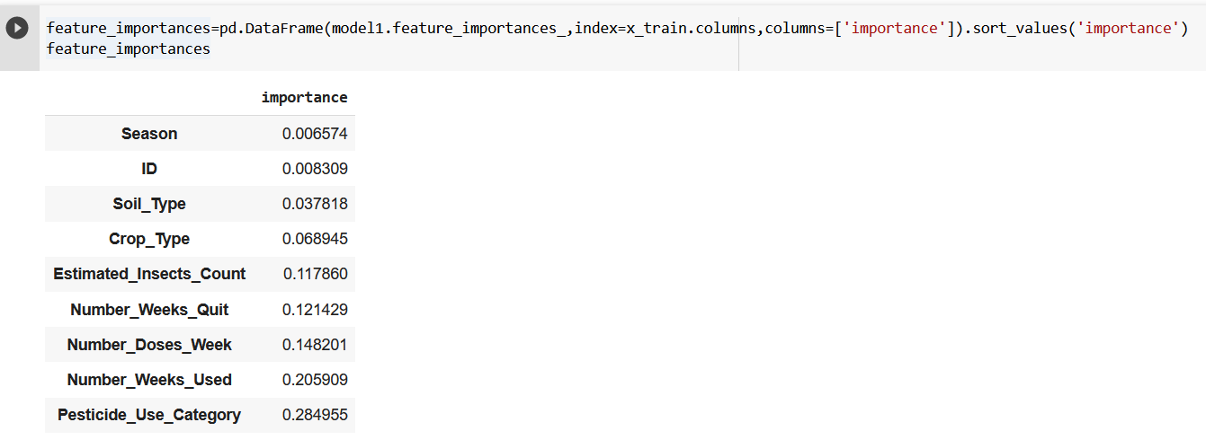

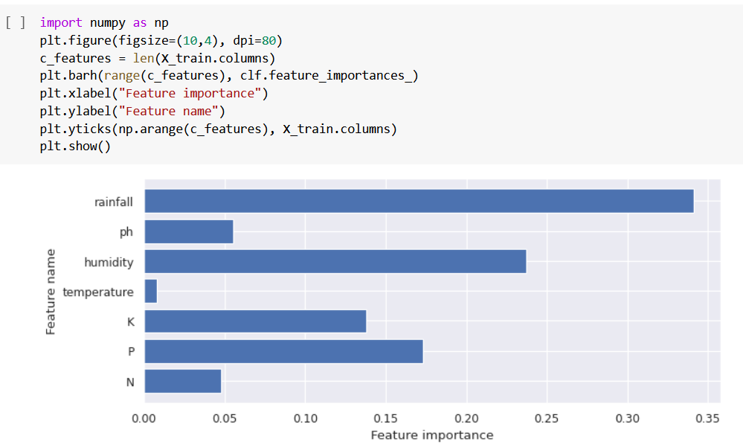

After the feature extraction process both the model’s accuracy proved to be improved

IV. **PERFORMANCE EVALUATION**

The machine learning algorithms that were used are:

1) Decision tree classifier

2) Gaussian Naive Bayes

3) Random Forest Classifier

4) Ensemble (XGB Classifier)

5) KNN

6) Logistic Regression

The measure and the metrics that were used are:

1) Precision

2) Recall

3) Accuracy

4) F1-score

1) Confusion matrix

1. **ACCURACY:**

Calculating classification accuracy involves dividing the total number of predictions by the fraction of true predictions, multiplied by 100. This measure is probably the simplest to use and execute. This can be done by contrasting in-loop forecasts versus ground truth. Use the sci-kit-learn module only.

ACCURACY = Number of correct predictions

Total number of predictions

1. **CONFUSION MATRIX:**

Confusion Matrix is a tabular depiction of the labels that serve as the model's "ground truth" for predictions. Actual class instances are shown in columns, while anticipated class instances are represented in rows. Although the confusion matrix isn't technically a performance indicator, it provides a foundation for other metrics used to assess outcomes.

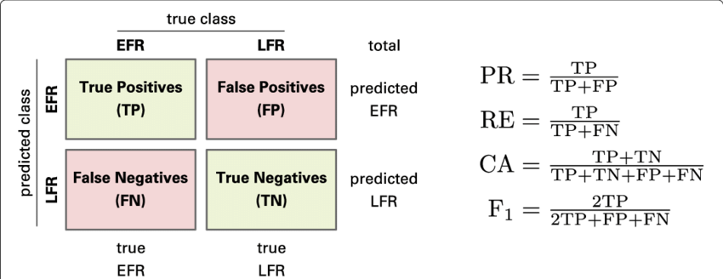

1. **PRECISION:**

The accuracy metric is the ratio of true positives to total predicted positives.

PRECISION = True Positive

(True Positive + False Positive)

1. **RECALL:**

Recall provides the ratio of true positives to all positives in the ground truth.

RECALL = True positive

(True Positive + False Negative)

1. **F1-SCORE:**

Precision and recall are combined in the F1 score metric. The harmonic mean of the two is the F1 score.

F1 = 2

1 + 1

Precision-Recall

**COMPARISON OF MODELS BASED ON THE ABOVE METRICS:**

DATASET: Classification - Crop Damages in India (2015-2019)

1. DECISION TREE CLASSIFIER:

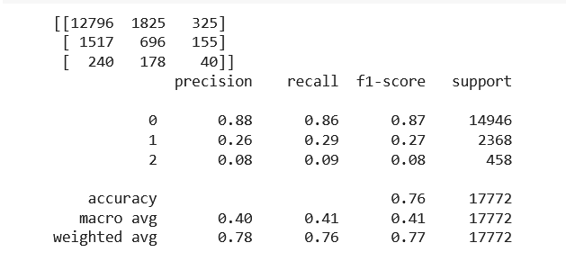

1. RANDOM FOREST CLASSIFIER:

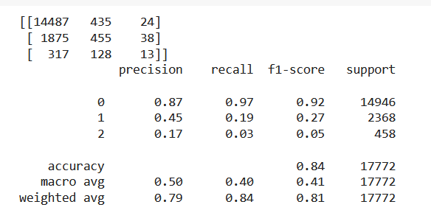

1. 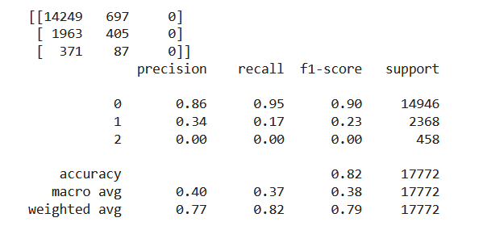GAUSSIAN NAÏVE BAYES:
2. 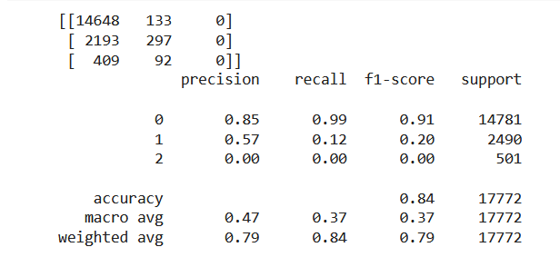XGB CLASSIFIER:
3. 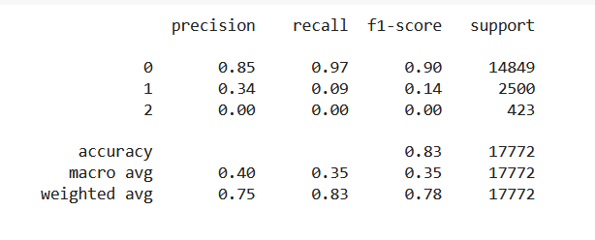KNN:
4. 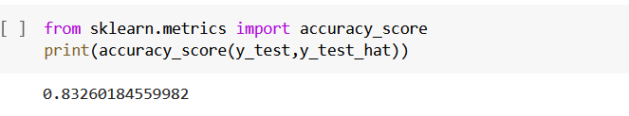LOGISTIC REGRESSION:

Comparing the results of the above models, we can conclude that the RANDOM FOREST CLASSIFIER and XGB CLASSIFIER models yield a higher accuracy of 84%. To further improve the two models above, a feature extraction process is performed by finding the importance of each feature in both data

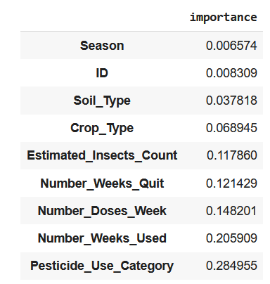. 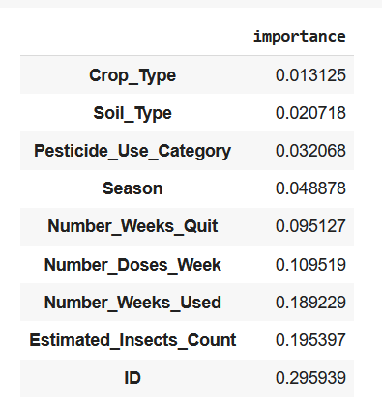

Here are the results after feature extraction:

RANDOM FOREST CLASSIFIER:

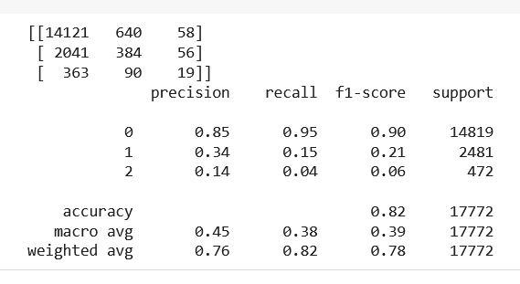

XGB CLASSIFIER:

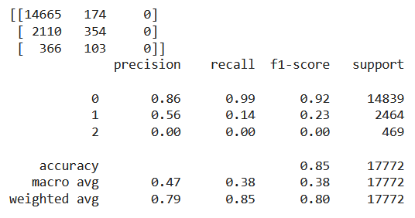

On comparing both results we infer that the accuracy has been increased in the XGB classifier from 84% to 85%.

DATASET 2: Crop analysis and prediction

1. 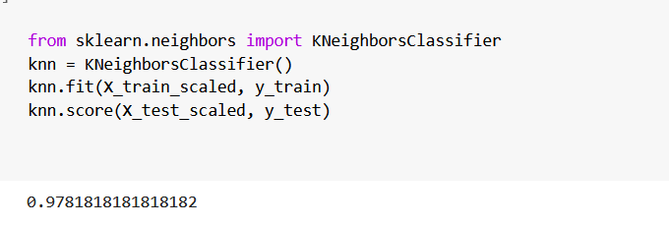KNN:
2. 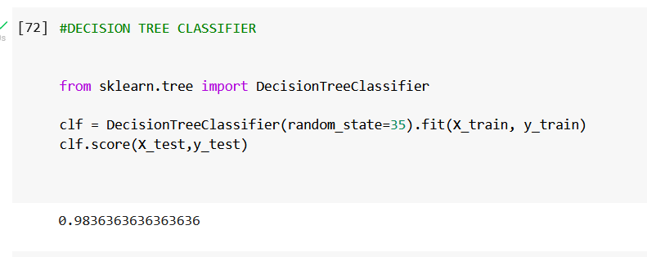DECISION TREE CLASSIFIER:
3. RANDOM FOREST CLASSIFIER:

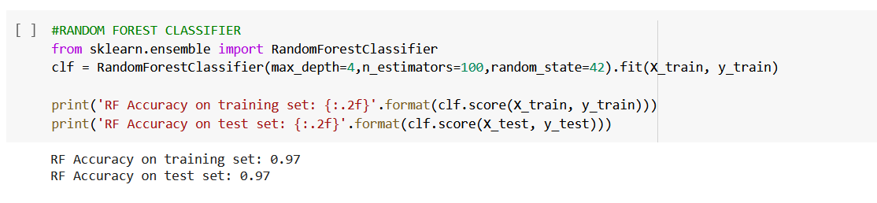

Comparing the results of the above models, we can conclude that the DECISION TREE CLASSIFIER model yields a high accuracy of 98.3%. By using a feature extraction process that uses only the significant features, the accuracy is improved to 98.9%.

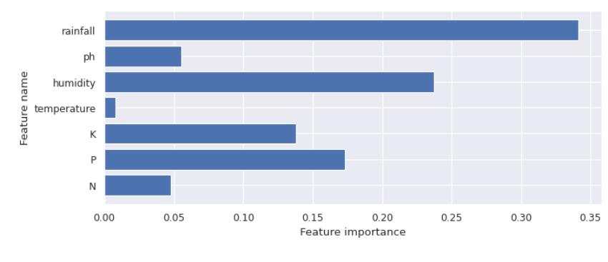

After Feature Extraction,

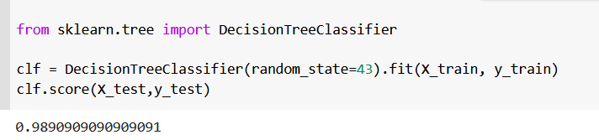

V. **CONCLUSION**

This study broadly addresses the importance of crop management, a time series model that can accurately detect disease and pest outbreaks based on weather conditions. Farmers need the latest technology to grow their crops. This is very useful as NDVI measurements provide information about plant development. Farmers can be notified of accurate harvest forecasts promptly. Research shows that models with more features do not always provide the best yield prediction performance. Evaluating models with more and fewer features is necessary to identify the model that performs the best. Deep learning models, however, need a lot of data, which is challenging to get. It is practical to employ transfer learning or low-shot learning techniques to address this issue. Additional research is required to assess photographs taken in the field under actual situations because deep learning-based algorithms perform well for images taken in controlled environments. Many algorithms have been used in various research papers. The results indicate that no definitive conclusions can be drawn about which model is best, indicating that some machine learning models are used more frequently than others. Therefore, by using machine learning algorithms, we may run into these problems. The accuracy of the XGB classifier improved from 84% to 85% on the crop damage level detection dataset after feature extraction. Similarly, the decision tree classifier for the plant species detection dataset was proven to have a high accuracy of 98%.

VI. **REFERENCES**

[1] Plantix App. Available online: https://plantix.net/en/ (accessed on 11 January 2022).

[2] Saillog. Available online: https://www.saillog.co/ (accessed on 11 January 2022).

[3] The Crop Diagnosis is Available at the following below link https://www.cropdiagnosis.com/portal/crops/en/home (accessed on 11 January 2022).

[4] Gamaya. Available online: https://www.gamaya.com/ (accessed on 11 January 2022).

[5] farmer. Available online: https://ifarmer.asia/ (accessed on 11 January 2022).

[5] Plant Village Tomato | Diseases and Pests, Description, Uses, Propagation. Available online: https://plantvillage.psu.edu/ topics/tomato/Infos (accessed on 11 January 2022).

[6] Significant the Remote Sensing Vegetation Indices a Review of Developments and Applications. Available online: https://www. hindawi.com/journals/JS/2017/1353691/ (accessed on 11 January 2022).

[7] Types of Morphological Operations MATLAB and Simulink. Available online: https://www.mathworks.com/help/images/ morphological-dilation-and-erosion.html. (Accessed on 11 January 2022). 35. Earth Observing System Vegetation Indices to Drive Digital Agri Solutions. Available online: https://eos.com/blog/vegetationindices/ (accessed on 11 January 2022).

[8] The Calculating Degree Days. Available at the following link online: https://www.degreedays.net/calculation (accessed on 26 July 2022).

[9] Food and Agriculture Organization of the United Nations FAOSTAT Pesticides Use. Available online

https://www.fao.org/ fast/en/#data/RP/visualize (accessed on 10 January 2022).

[10] Bhuyan, B.P.; Tomar, R.; Cherif, A.R. A Systematic Review of Knowledge Representation Techniques in Smart Agriculture (Urban). Sustainability 2022, 14, 15249. [CrossRef]

[11] Kartikeyan, P.; Shrivastava, G. Review on emerging trends in the detection of plant diseases using image processing with machine learning. Int. J. Comput. Appl. 2021, 975, 8887. [CrossRef]

[12] Moysiadis, V.; Sarigiannidis, P.; Vitsas, V.; Khelifi, A. Smart farming in Europe. Comput. Sci. Rev. 2021, 39, 100345. [CrossRef]

[13] Dimov, D. Classification of remote sensing time series and similarity metrics for crop type verification. J. Appl. Remote. Sens. 2022, 16, 024519. [CrossRef]

[14] Orynbaikyzy, A.; Gessner, U.; Conrad, C. Spatial Transferability of Random Forest Models for Crop Type Classification Using Sentinel-1 and Sentinel-2. Remote Sens. 2022, 14, 1493. [CrossRef]

[15] Han, X.; Wei, Z.; Zhang, B.; Li, Y.; Du, T.; Chen, H. Crop evapotranspiration prediction by considering dynamic change of crop coefficient and the precipitation effect in back-propagation neural network model. J. Hydrol. 2021, 596, 126104. [CrossRef]

[16] Potgieter, A.B.; Zhao, Y.; Zarco-Tejada, P.J.; Chenu, K.; Zhang, Y.; Porker, K.; Biddulph, B.; Dang, Y.P.; Neale, T.; Roosta, F.; et al. Evolution and application of digital technologies to predict crop type and crop phenology in agriculture. In Silico Plants 2021, 3, Diab017. [CrossRef]

[17] Choudhuri, K.B.R.; Mangrulkar, R.S. Data Acquisition and Preparation for Artificial Intelligence and Machine Learning Applications. In Design of Intelligent Applications Using Machine Learning and Deep Learning Techniques; Chapman and Hall/CRC: Boca Raton, FL, USA, 2021; pp.

[18] Fenu, G.; Malloci, F.M. Forecasting plant, and crop disease: An explorative study on current algorithms. Big Data Cogn. Comput. 2021, 5, 2. [CrossRef]

[19] Soni, A.; Dharmacharya, D.; Pal, A.; Srivastava, V.K.; Shaw, R.N.; Ghosh, A. Design of a machine learning-based self-driving car. In Machine Learning for Robotics Applications; Springer: Berlin/Heidelberg, Germany, 2021; pp. 139–151.

[20] Chandel, A.K.; Khot, L.R.; Salato, B. Apple powdery mildew infestation detection and mapping using a high-resolution visible and multispectral aerial imaging technique. Sci. Hortic. 2021, 287, 110228. [CrossRef]

[21] Bhuyan, B.P.; Tomar, R.; Gupta, M.; Ramdane-Cherif, A. An Ontological Knowledge Representation for Smart Agriculture. In Proceedings of the 2021 IEEE International Conference on Big Data (Big Data), Orlando, FL, USA, 15–18 December 2021. [CrossRef]

[22] Chandel, A.K.; Khot, L.R.; Sallato, B. Apple powdery mildew infestation detection and mapping using high-resolution visible and multispectral aerial imaging technique. Sci. Hortic. 2021, 287, 110228. [[Google Scholar](https://scholar.google.com/scholar_lookup?title=Apple+powdery+mildew+infestation+detection+and+mapping+using+high-resolution+visible+and+multispectral+aerial+imaging+technique&author=Chandel,+A.K.&author=Khot,+L.R.&author=Sallato,+B.&publication_year=2021&journal=Sci.+Hortic.&volume=287&pages=110228&doi=10.1016/j.scienta.2021.110228)] [[CrossRef](https://doi.org/10.1016/j.scienta.2021.110228)]

[23] Tan, L.; Lu, J.; Jiang, H. Tomato Leaf Diseases Classification Based on Leaf Images: A Comparison between Classical Machine Learning and Deep Learning Methods. AgriEngineering 2021, 3, 542–558. [[Google Scholar](https://scholar.google.com/scholar_lookup?title=Tomato+Leaf+Diseases+Classification+Based+on+Leaf+Images:+A+Comparison+between+Classical+Machine+Learning+and+Deep+Learning+Methods&author=Tan,+L.&author=Lu,+J.&author=Jiang,+H.&publication_year=2021&journal=AgriEngineering&volume=3&pages=542%E2%80%93558&doi=10.3390/agriengineering3030035)] [[CrossRef](https://doi.org/10.3390/agriengineering3030035" \t "_blank)]

[24] Yaramasu, R.; Bandaru, V.; Pnvr, K. Pre-season crop type mapping using deep neural networks. Comput. Electron. Agric. 2020, 176, 105664. [CrossRef]

[25] Pott, L.P.; Amado TJ, C.; Schwalbert, R.A.; Corassa, G.M.; Ciampitti, I.A. Satellite-based data fusion crop type classification and mapping in Rio Grande do Sul, Brazil. ISPRS J. Photogramm. Remote. Sens. 2021, 176, 196–210. [CrossRef]

[26] Babaee, M.; Maroufpoor, S.; Jalali, M.; Zarei, M.; Elbeltagi, A. Artificial intelligence approach to estimating rice yield. Irrig. Drain. 2021, 70, 732–742. [CrossRef]

[27] Dziak, J.J.; Coffman, D.L.; Lanza, S.T.; Li, R.; Jermiin, L.S. Sensitivity and specificity of information criteria. Briefings Bioinform. 2020, 21, 553–565. [CrossRef]

[28] Wojtas, M.; Chen, K. Feature importance ranking for deep learning. Adv. Neural Inf. Process. Syst. 2020, 33, 5105–5114.

[29] Ali, M.; Jung, L.T.; Abdel-Aty, A.H.; Abubakar, M.Y.; Elhoseny, M.; Ali, I. Semantic-k-NN algorithm: An enhanced version of traditional k-NN algorithm. Expert Syst. Appl. 2020, 151, 113374. [CrossRef]

[30] Singh, D.; Jain, N.; Jain, P.; Kayal, P.; Kumawat, S.; Batra, N. PlantDoc: A dataset for visual plant disease detection. In Proceedings of the 7th ACM IKDD CoDS and 25th COMAD, Hyderabad, India, 5–7 January 2020; pp. 249–253.

[31] Carleo, G.; Cirac, I.; Cranmer, K.; Daudet, L.; Schuld, M.; Tishby, N.; Vogt-Maranto, L.; Zdeborová, L. Machine learning and the physical sciences. Rev. Mod. Phys. 2019, 91, 045002. [CrossRef]

[32] Fróna, D.; Szenderák, J.; Harangi-Rákos, M. The challenge of feeding the world. Sustainability 2019, 11, 5816. [CrossRef]

[33] Deutsch, C.A.; Tewksbury, J.J.; Tigchelaar, M.; Battisti, D.S.; Merrill, S.C.; Huey, R.B.; Naylor, R.L. Increase in crop losses to insect pests in a warming climate. Science 2018, 361, 916–919. [CrossRef] [PubMed]

[34] FAO. The Future of Food and Agriculture: Trends and Challenges; FAO: Rome, Italy, 2019.

[35] Jha, K.; Doshi, A.; Patel, P.; Shah, M. A comprehensive review on automation in agriculture using artificial intelligence. Artif. Intell. Agric. 2019, 2, 1–12. [CrossRef] 21. Bannerjee, G.; Sarkar, U.; Das, S.; Ghosh,

[36] Ali, M.; Mubeen, M.; Hussain, N.; Wajid, A.; Farid, H.U.; Awais, M.; Hussain, S.; Akram, W.; Amin, A.; Akram, R.; et al. Role of ICT in crop management. In Agronomic Crops; Springer: Singapore, 2019; pp. 637–652.

[37] Heitlinger, S.; Bryan-Kinns, N.; Comber, R. The right to the sustainable smart city. In Proceedings of the 2019 CHI Conference on Human Factors in Computing Systems, Glasgow, UK, 4–9 May 2019.

[38] Khaki, S.; Wang, L. Crop yield prediction using deep neural networks. Front. Plant Sci. 2019, 10, 621. [CrossRef] [PubMed]

[39] Panigrahi, R. Trends in Agricultural Production and Productivity Growth in India: Challenges to Sustainability. In Business Governance and Society; Palgrave Macmillan: Cham, Switzerland, 2019; pp. 17–28.

[40] Kc, S.; Wurzer, M.; Speringer, M.; Lutz, W. Future population and human capital in heterogeneous India. Proc. Natl. Acad. Sci. USA 2018, 115, 8328–8333. [CrossRef] [PubMed]

[41] Mc Carthy, U.; Uysal, I.; Badia-Melis, R.; Mercier, S.; O’Donnell, C.; Ktenioudaki, A. Global food security–Issues, challenges and technological solutions. Trends Food Sci. Technol. 2018, 77, 11–20. [CrossRef]

[42] Bach, H.; Wolfram, M. Sustainable agriculture and smart farming. In Earth Observation Open Science and Innovation; Springer: Cham, Switzerland, 2018; pp. 261–269.

[43] Liakos, K.G.; Busato, P.; Moshou, D.; Pearson, S.; Bochtis, D. Machine learning in agriculture: A review. Sensors 2018, 18, 2674. [CrossRef] [PubMed]

[44] de Jong, S. Crop Type Prediction Based on Farmers Declarations. Master’s Thesis, Utrecht University, Utrecht, The Netherlands, 2018.

[45] Bannerjee, G.; Sarkar, U.; Das, S.; Ghosh, I. Artificial intelligence in agriculture: A literature survey. Int. J. Sci. Res. Comput. Sci. Appl. Manag. Stud. 2018, 7, 1–6.

[46] Smith, M.J. Getting value from artificial intelligence in agriculture. Anim. Prod. Sci. 2018, 60, 46–54. [CrossRef]

[47] Charoen-Ung, P.; Mittrapiyanuruk, P. Sugarcane yield grade prediction using random forest and gradient boosting tree techniques. In Proceedings of the 2018 15th International Joint Conference on Computer Science and Software Engineering (JCSSE), Nakhonpathom, Thailand, 11–13 July 2018.

[48] Betke, M.; Wu, Z. Evaluation criteria. In Data Association for Multi-Object Visual Tracking; Springer: Cham, Switzerland, 2017; pp. 29–35.

[49] Jordan, M.I.; Mitchell, T.M. Machine learning: Trends, perspectives, and prospects. Science 2015, 349, 255–260. [CrossRef] [PubMed]

[50] Dahikar, S.S.; Rode, S.V. Agricultural crop yield prediction using artificial neural network approach. Int. J. Innov. Res. Electr. Electron. Instrum. Control. Eng. 2014, 2, 683–686.